Prototyping
- Prototypes are a useful aid when discussing ideas with stakeholders; they are a communication device among team members, and are an effective way to test out ideas for yourself.

- Liddle (1996), talking about software design, recommends that prototyping should always precede any writing of code.

- Prototypes answer questions and support designers in choosing between alternatives.

- Hence, they serve a variety of purposes: for example,

  - To test out the technical feasibility of an idea,
  - To clarify some vague requirements,
  - To do some user testing and evaluation,
  - or to check that a certain design direction is compatible with the rest of the system development.

- Which of these is your purpose will influence the kind of prototype you build. So, for example,
  - if you are trying to clarify how users might perform a set of tasks and whether your proposed device would support them in this, you might produce a paper-based mockup.

Low-fidelity prototyping
- A low-fidelity prototype is one that does not look very much like the final product. For example, it uses materials that are very different from the intended final version, such as paper and cardboard rather than electronic screens.

- Low-fidelity prototypes are useful because they tend to be simple, cheap, and quick to produce. This also means that they are simple, cheap, and quick to modify so they support the exploration of alternative designs and ideas.

- This is particularly important in early stages of development, during conceptual design for example, because prototypes that are used for exploring ideas should be flexible and encourage rather than discourage exploration and modification.

- Low-fidelity prototypes are never intended to be kept and integrated into the final product. They are for exploration only.

Storyboarding
- Storyboarding is one example of low-fidelity prototyping that is often used in conjunction with scenarios.

- A storyboard consists of a series of sketches showing how a user might
progress through a task using the device being developed, it can be a series of sketched screens for a GUI-based software system, or a series of scene sketches showing how a user can perform a task using the device.

- When used in conjunction with a scenario, the storyboard brings more detail to the written scenario and offers stakeholders a chance to role-play with the prototype, interacting with it by stepping through the scenario.

Sketching
- Low-fidelity prototyping often relies on sketching, and many people find it difficult to engage in this activity because they are inhibited about the quality of their drawing.
- Elements you might require in a storyboard sketch, for example, include "things" such as people, parts of a computer, desks, books, etc., and actions such as give, find, transfer, and write. If you are sketching an interface design, then you might need to draw various icons, dialog boxes, and so on.

Wireframes
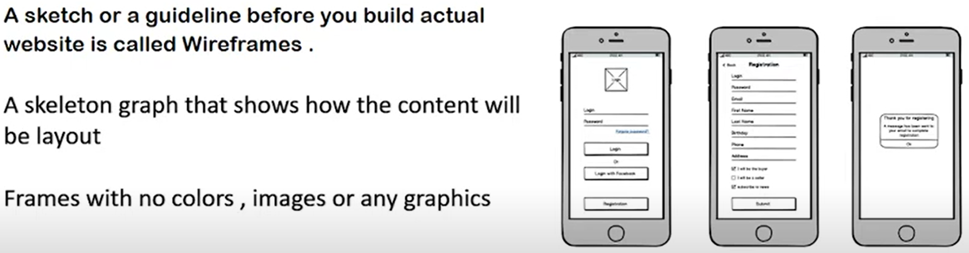
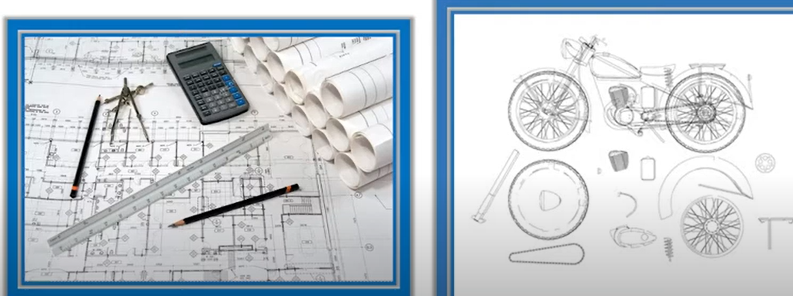

High-fidelity prototyping
- High-fidelity prototyping uses materials that you would expect to be in the final product and produces a prototype that looks much more like the final thing. For example, a prototype of a software system developed in Visual Basic is higher fidelity than a paper based mockup.

- If you are to build a prototype in software, then clearly you need a software tool to support this. Common prototyping tools include Macromedia Director, Visual Basic, Smalltalk, and Figma. These are also full-fledged development environments, so they are powerful tools, but building prototypes using them can also be very straightforward.

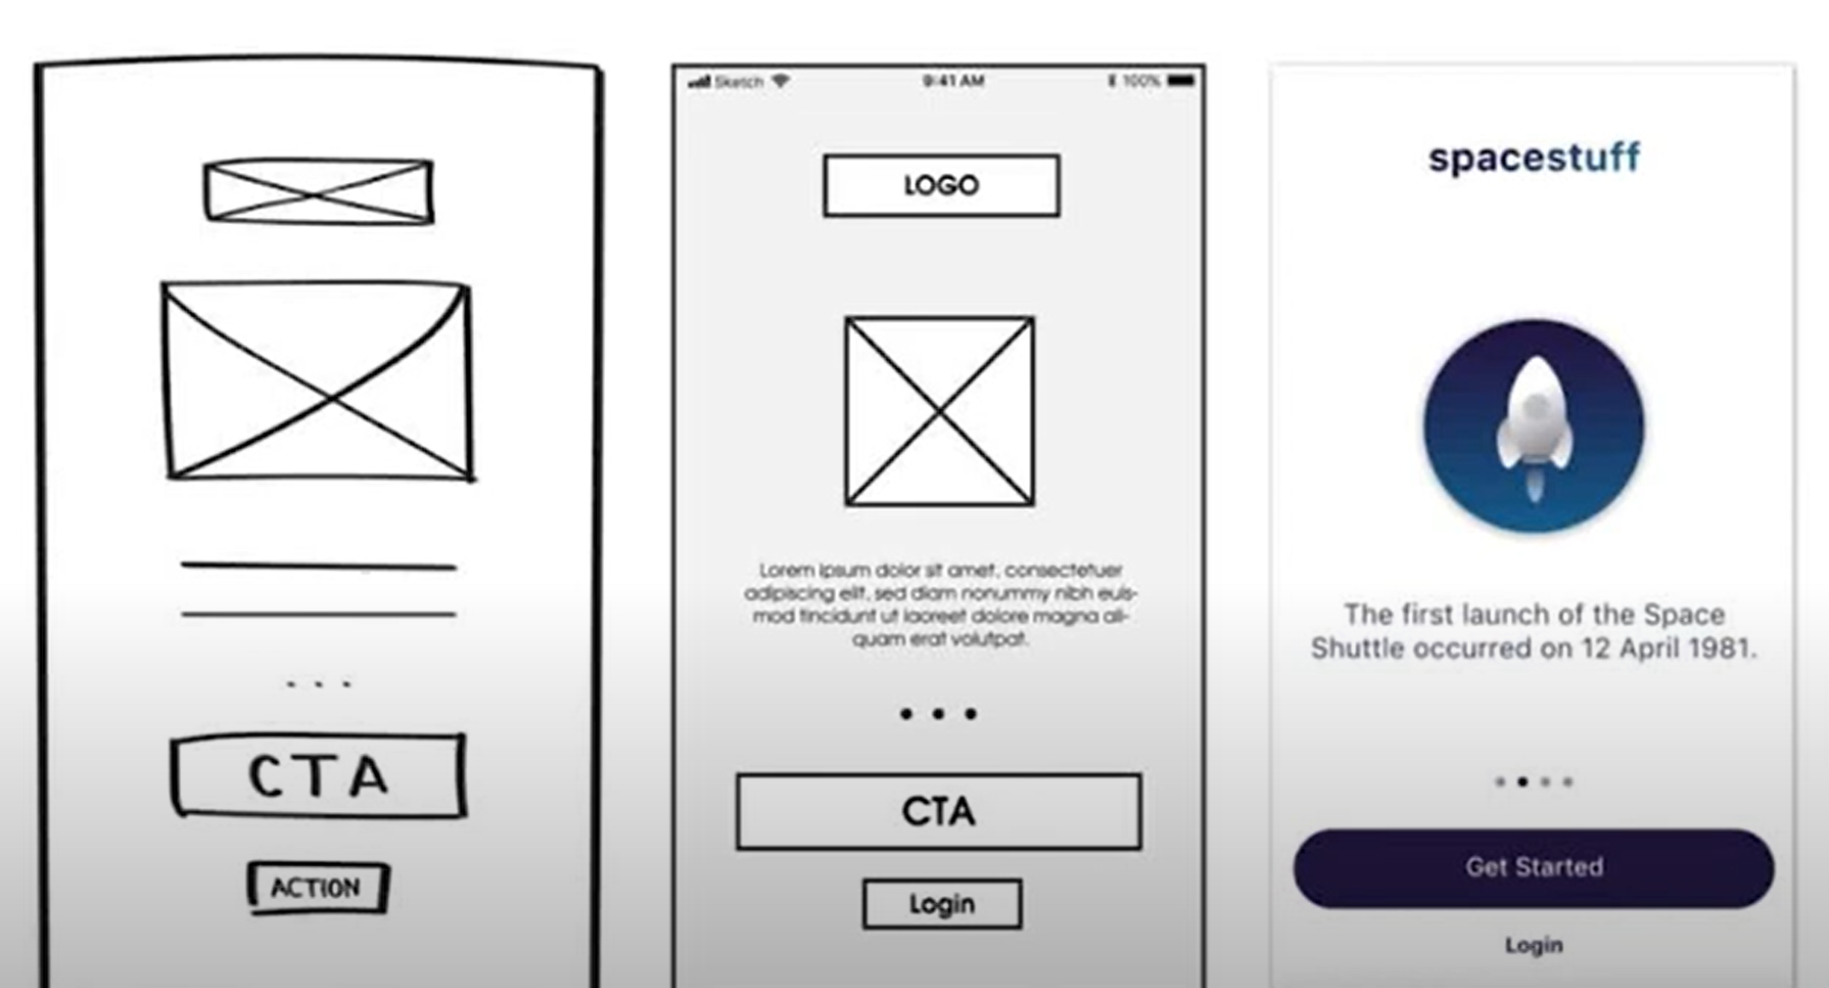
Design phases, 1. design on paper , and no detail 2. design on paper but with detail 3. Design it in tools e.g Figma etc.

